**CHEMSWEEP**

CHEMSWEEP provides Pennsylvania farmers and other licensed pesticide applicators with a means to dispose of canceled, suspended or unwanted pesticide products.

**Over 3.3 million pounds of unwanted pesticides collected**

Through CHEMSWEEP, applicators can dispose of unwanted pesticides legally and often for free. Most waste pesticides are incinerated. The rest go to hazardous waste landfills.

Every year, CHEMSWEEP operates in select counties. Licensed farmers, pesticide applicators, and businesses in these counties can join. If you're in agriculture, pest control, lawn care, or selling pesticides, check out the [2025 CHEMSWEEP map](https://www.pa.gov/content/dam/copapwp-pagov/en/pda/documents/plants_land_water/plantindustry/health-safety/environmental-programs/documents/2025%20chemsweep%20map.pdf). If your county is eligible, fill out the registration form [here](https://survey123.arcgis.com/share/677cd095b0a849909feee18539b552a7?portalUrl=https://PADeptAG.maps.arcgis.com) and submit it by **March 31, 2025.**

**Note - The Public Inventory Submissions website opens in December.**A Pennsylvania Department of Agriculture (PDA) inspector will verify pesticide inventories from farmers and licensed applicators. Then, PDA will arrange collections with a contractor, usually from July to October. CHEMSWEEP covers the first 2,000 pounds per participant.

The program only accepts pesticides registered in the Commonwealth. These are called Universal Waste Pesticides. They will be collected and disposed of according to regulations. The contractor becomes the official generator of your waste pesticides at collection.

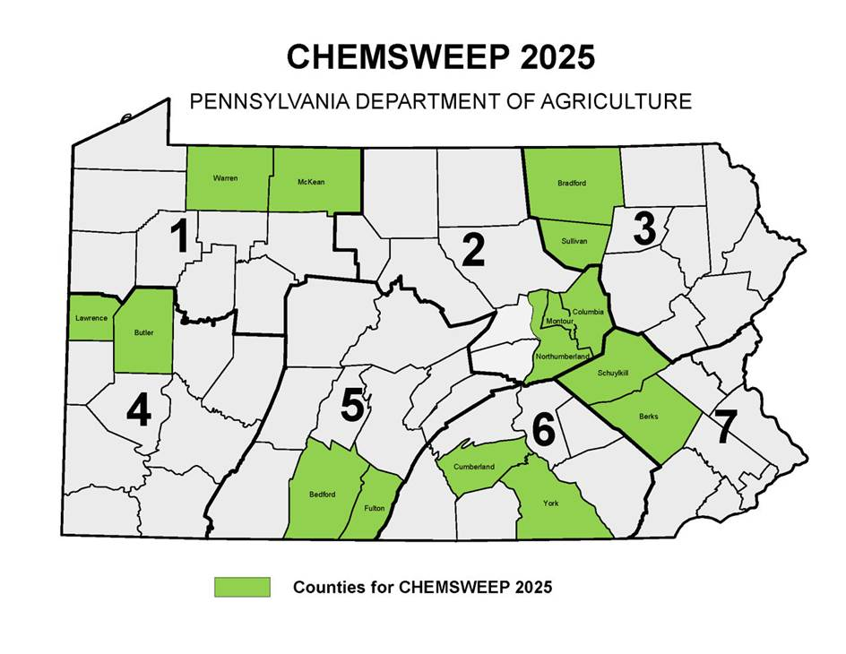

**Future Collections**

**2025:**Bedford, Berks, Bradford, Butler, Columbia, Cumberland, Fulton, Lawrence, McKean, Montour, Northumberland, Schuylkill, Sullivan, York, and Warren.

2026: Adams, Allegheny, Beaver, Cameron, Carbon, Centre, Chester, Clearfield, Clinton, Elk, Franklin, Jefferson, Lancaster, Lehigh, Monroe, Northampton, Pike, Potter, Washington.

2027: Bucks, Crawford, Dauphin, Erie, Fayette, Greene, Huntingdon, Juniata, Lycoming, Mercer, Mifflin, Montgomery, Perry, Philadelphia, Susquehanna, Tioga, Wayne, Westmoreland.

2028: Armstrong, Blair, Cambria, Chester, Clarion, Delaware, Forest, Indiana, Lackawanna, Lancaster, Lebanon, Luzerne, Snyder, Somerset, Union, Venango, Wyoming.